Lapeer County Community Foundation



WOMEN’S FUND

**MINI GRANT APPLICATION**

This form is to be submitted upon a referral from a Lapeer County Community Foundation

Women’s Fund partner agency. A mini grant is to be considered when all other avenues have

been pursued by the applicant and they do not meet the criteria for agency assistance. Funds

are for last resort financing for emergency needs that would otherwise fall through the cracks

in other organizations! **Mini grant awards are $1,000 or less.**

***Referring Partner Agency:***

***Grantee information***

**Name:**

**Address:**

**City/State/Zip:**

**Cell phone:** **Home phone:**

**Email:**

**Purpose of grant:**

***Financing information***

**Total project cost:** **Amount requested:**

**Amount funded by others:**

**Other agencies, individuals, organizations, etc. to which you have requested funds:**

ATTACH LETTER(S) OF SUPPORT VERIFYING THE GRANT NEEDS AND COLLABORATION WITH OTHER ORGANIZATIONS AND/OR AGENCIES WHEN APPLICABLE.

🟅 🟅 🟅

*The undersigned hereby acknowledges the information provided on this application*

*is true and correct to the best of her knowledge.*

**Applicant: _________________________ Date: ________________**

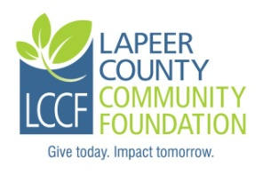Lapeer County Community Foundation

235 W. Nepessing St.

Lapeer, MI 48446

(810) 664-0691

[nboxey@lapeercountycf.org](mailto:nboxey@lapeercountycf.org)

www.lapeercountycf.org