Lapeer County Community Foundation

WOMEN’S FUND

**Partner Organization/Agency**

**Application**



The Women’s Fund works in collaboration with partner agencies in providing mini-grants to

meet the needs of Lapeer County women and their children in areas of crisis funding for last

resort or emergency needs. Partners provide applicant referrals for those who do not meet the

criteria for their agency funding. They also serve as the fiscal sponsor for grant funds awarded.

**Organization/Agency Description**

**Organization/Agency name:**

**Address:**

**City/state/zip:**

**Director:** **Phone(s):**

**Fax:** **Email:**

**Organization/Agency type: Public**  **Private**  **Total membership:**

**Non-profit? Yes**  **No**  **Government? Yes** **No**

**Federal tax exempt? Yes**  **No** **Tax exempt number:**

**Brief statement of organization/agency purpose:**

Attachments:

1. **A copy of the current IRS determination letter indicating 501(c)(3) tax exempt status**
2. **List of Board of Directors and their affiliations**
3. **Financial information**

**a) Organization’s current annual operating budget, including expenses and revenue**

* 1. **Most recent annual financial statement (independently audited, if available; if not available, attach form 990**

**4. Annual Report, if available**

*As a Partner Organization/Agency we agree to serve as the fiscal sponsor for LCCF Women’s Fund mini grants. By accepting this responsibility, we acknowledge that payments will be processed within fourteen (14) days of receipt of LCCF funds.*

**Executive Director Date________________**

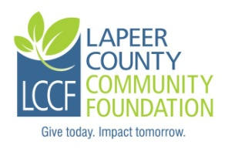

Lapeer County Community Foundation

235 W. Nepessing St., Lapeer, MI 48446

(810) 664-0691 [nboxey@lapeercountycf.org](mailto:nboxey@lapeercountycf.org)

www.lapeercountycf.org