Lapeer County Community Foundation

Jack and Carolyn Griffin
Memorial Scholarship Application
Part One
The Jack and Carolyn Memorial Scholarship Fund was established in 2009 as a living tribute to Walker and Fern Griffin, former residents of North Branch.

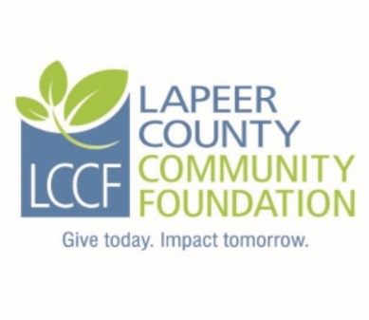
PART ONE is for residents of Lapeer County and graduating seniors of North Branch High School.

PART TWO is for residents of Lapeer County and past recipients of the Jack and Carolyn Griffin Memorial Scholarship (Part Two is attached below Part One.)

PART ONE:
Criteria: Applicant must be a graduating senior of North Branch High School and must be accepted by an accredited post-secondary degree granting college, university or trade school. Preference will be given to students who exhibit exceptional personal qualities, especially excellent attendance, honesty, sensitivity and service to others. Minimum cumulative GPA of 2.5 required for secondary studies. A personal interview may be requested by the scholarship selection committee. Award: (5) - $1,000 scholarships

Instructions: Complete the fillable application, print, sign and date. It may be necessary to click on “Enable Editing” command at the top of the screen.

Personal Information:
Last Name: | First name: | Middle Initial:
Address: |  | City:
Zip Code: | Township: | County:
Home phone: | Student cell: | Date of Birth:
Student ID #: | Student email:
Parents/Guardians:

Adjusted Gross Household Income: | # of Children in Household: | # of Children in College:

Student Experiences and Activities:
High School Attending: | Graduation date: | Cumulative GPA:
Colleges or vocational schools attended (if any):

School activities and involvement/leadership positions:

Community and non-school activities:

Employment history:

Anticipated profession or area of vocational interest:

Colleges, vocational schools and/or academies applied to and accepted at (in order of preference):
Anticipated costs for 1 year:
1)
2)
3)

List of other scholarships, grants or financial aid applied for:
Name Amount of award Awarded? Yes, No, Pending

How did you hear about this scholarship?

Student Essay Question (Limit your answer to 200 words, responding to each of the following:
(a) What are your immediate and long term goals? (b) People and events shape our lives. Name one person or event that has influenced your life and why. (c) How have you shown concern and provided service for the welfare of other students and the community?

I, the undersigned, hereby acknowledge the information provided on this application is true and correct to the best of my knowledge.

Student applicant:__________________________________________Date:________________

Required Attachments:
1. Current transcript showing credits earned and current GPA. 2. Copy of SAT scores if you are a graduating high school senior.
3. Copy of your current year FAFSA Student Aid Report (SAR). Please only submit the page
that shows the EFC (Estimated Family Contribution).
4. A letter of recommendation (optional).
Submission Instructions:
- Please do not submit double sided copies or use staples.
- Please submit an original signed application including all attachments along with six complete
copies for a total of seven complete packets.
- Please paperclip each complete packet.
- Please mail all seven packets in one envelope to the committee and address listed below.
- If you are applying for more than one scholarship through LCCF, please do not combine different named scholarships in one envelope as they have different committees.

Application must be postmarked NO LATER THAN Friday, March 15, 2019

Mail to: Jack and Carolyn Griffin Scholarship Committee-Part One
LCCF
235 W. Nepessing Street
Lapeer, MI 48446

Questions may be directed to:

Nancy Boxey, Executive Director
Phone: 810 664-0691
Email: nboxey@lapeercountycf.org

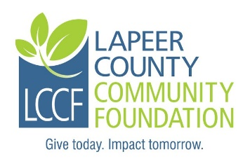

Lapeer County Community Foundation

Jack and Carolyn Griffin
Memorial Scholarship Application
Part Two

The Jack and Carolyn Memorial Scholarship Fund was established in 2009 as a living tribute to Walker and Fern Griffin,
former residents of North Branch.

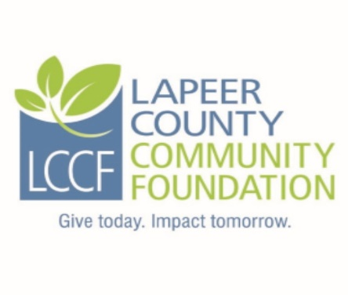

PART TWO is for residents of Lapeer County and past recipients of the Jack and Carolyn Griffin Memorial Scholarship.

PART TWO CRITERIA:
Applicant must be a past recipient of the Jack and Carolyn Griffin Memorial Scholarship and enrolled in an accredited post-secondary degree granting college, university or trade school. Preference will be given to students who exhibit exceptional personal qualities, especially honesty, sensitivity and service to others. Minimum cumulative GPA of 2.5 required for post-secondary studies.
Award: (2) - $1,000 scholarships

Instructions: Complete the fillable application, print, sign and date. It may be necessary to click on “Enable Editing” command at the top of the screen.
Personal Information:
Last Name: | First name: | Middle Initial:
Address: |  | City:
Zip Code: | Township: | County:
Home phone: | Student cell: | Date of Birth:
Student ID #: | Student email:
Parents/Guardians:

In what year(s) were you a recipient of the Jack and Carolyn Griffin Memorial Scholarship?
Adjusted Gross Household Income: | # of Children in Household: | # of Children in College:

Student Experiences and Activities:

College/school attending: | Anticipated graduation date: | Cumulative GPA: | Anticipated costs for 1 year:
School activities and involvement/leadership positions:

Community and non-school activities:

Employment history:

Anticipated profession or area of vocational interest:

List of other scholarships, grants or financial aid applied for:

Name Amount of award Awarded? Yes, No, Pending

Student Essay Question (Limit your answer to 200 words, responding to each of the following:
(a) What are your immediate and long term goals? (b) People and events shape our lives. Name one person or event that has influenced your life and why. (c) How have you shown concern and provided service for the welfare of other students and the community?

I, the undersigned, hereby acknowledge the information provided on this application is true and correct to the best of my knowledge.

Student applicant: ___________________________________________Date:________________

Required Attachments:
1. Current transcript showing credits earned and current GPA.
2. Copy of your current year FAFSA Student Aid Report (SAR). Please only submit the page
that shows the EFC (Estimated Family Contribution).
3. A letter of recommendation (optional).
Submission Instructions:
- Please do not submit double sided copies or use staples.
- Please submit an original signed application including all attachments along with six complete
copies for a total of seven complete packets.
- Please paperclip each complete packet.
- Please mail all seven packets in one envelope to the committee and address listed below.
- If you are applying for more than one scholarship through LCCF, please do not combine different named scholarships in one envelope as they have different committees.

Application must be postmarked NO LATER THAN Friday, March 15, 2019

Mail to: Jack and Carolyn Griffin Scholarship Committee-Part Two
LCCF
235 W. Nepessing Street
Lapeer, MI 48446

Questions may be directed to:

Nancy Boxey, Executive Director
Phone: 810 664-0691
Email: nboxey@lapeercountycf.org

