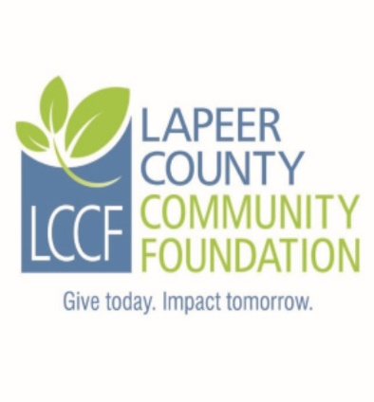
Lapeer County Community Foundation
IRMA GELHAUSEN SCHOLARSHIP APPLICATION
The Irma Gelhausen Scholarship was established to develop and encourage teachers who best emulate the qualities of commitment to well-rounded education and social values. Applicants must be in the third year or more of college/university studies and pursuing a career in elementary or secondary education. Applicant must possess a cumulative GPA of 3.0 or higher for post-secondary studies and be a resident of Lapeer County. Preference is given to graduates of Lapeer High School and those pursuing elementary education.

Instructions: Complete the fillable application, print, sign and date. It may be necessary to click on “Enable Editing” command at the top of the screen.

Personal Information:
Last Name: | First name: |  | Middle Initial:
Address: |  |  | City:
Zip Code: | Township: |  | County:
Home phone: | Student cell: |  | Date of Birth:
Student ID #: | Student email:
Parents/Guardians:

Adjusted Gross Household Income: | # of Children in Household: |  | # of Children in College:

Student Experiences and Activities:

High School Attended: | High School Graduation date: | Current College GPA:
Colleges attended/degree earned (if any):

College activities and involvement/leadership positions:

Community and non-school activities:

Employment history:

Anticipated profession or area of vocational interest:

Anticipated costs of attendance for one year:

List of other scholarships, grants or financial aid applied for:

Name Amount of award Awarded? Yes, No, Pending

Student Essay Question (Limit your answer to 200 words).

What do you hope to achieve as an educator with your college education?

I, the undersigned, hereby acknowledge the information provided on this application is true and correct to the best of my knowledge.

Student applicant:___________________________________________Date:________________

Required Attachments:
1. Current transcript showing credits earned and current GPA.
2. Copy of your current year FAFSA Student Aid Report (SAR). Please only submit the page
that shows the EFC (Estimated Family Contribution).
3. A letter of recommendation (optional).
Submission Instructions:
- Please do not submit double sided copies or use staples.
- Please submit an original signed application including all attachments along with six complete
copies for a total of seven complete packets.
- Please paperclip each complete packet.
- Please mail all seven packets in one envelope to the committee and address listed below.
- If you are applying for more than one scholarship through LCCF, please do not combine different named scholarships in one envelope as they have different committees.

Application must be postmarked NO LATER THAN Friday, March 13, 2020

Mail to:
Irma Gelhausen Scholarship Committee
LCCF
235 W. Nepessing Street
Lapeer, MI 48446

Questions may be directed to:

Nancy Boxey, Executive Director
Phone: 810 664-0691
Email: nboxey@lapeercountycf.org

