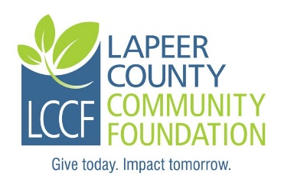
Lapeer County Community Foundation
General Scholarship Application

Check one:

Broesamle: Must be a resident of Dryden or Dryden Township or Almont or Almont Township.

Medical: Must be a resident of Lapeer County; at least a second-year enrolled college student in a pre-science medical professional program such as medical, dental, nursing or physician’s assistant; 3.2 GPA or higher.

Instructions: Complete the fillable application, print, sign and date. It may be necessary to click on “Enable Editing” command at the top of the screen.

Personal Information:

Last Name: | First name: | Middle Initial:
Address: |  | City:
Zip Code: | Township: | County:
Home phone: | Student cell: | Date of Birth:
Student ID #: | Student email:
Parents/Guardians:

Adjusted Gross Household Income: | # of Children in household: | # of Children in College:

Student Experiences and Activities:

High School Attended: | High School Graduation date: | Current GPA:
Colleges attended/degree earned (if any):

School activities and involvement/leadership positions:

Community and non-school activities:

Employment history (Name of employer, name of manager, and position (up to 3 employers):

Anticipated profession or area of vocational interest::

Colleges, vocational schools and/or academies applied to and accepted at (in order of preference):
Anticipated costs for 1 year:
1) Click or tap here to enter text.
2)
3)

List of other scholarships, grants or financial aid applied for:

Name Amount of award Awarded? Yes, No, Pending

Student Essay Question (Limit your answer to 200 words).

What do you hope to achieve with your college education?

How did you hear about this scholarship?

I, the undersigned hereby acknowledge the information provided on this application is true and correct to the best of my knowledge.

Student applicant:___________________________________________Date:________________

Required Attachments:
1. Current transcript showing credits earned and current GPA.
2. Copy of SAT scores if you are a graduating high school senior.
3. Copy of your current year FAFSA Student Aid Report (SAR). Please only submit the page that
Shows EFC (Estimated Family Contribution)
4. A letter of recommendation (optional)

Submission Instructions:
- Please do not submit double sided copies or use staples.
- Please submit an original signed application including all attachments along with six
complete copies for a total of seven complete packets.
- Please paperclip each complete packet.
- Please mail all seven packets in one envelope to the committee and address listed below.
- If you are applying for more than one scholarship through LCCF, please do not combine
different named scholarships in one envelope as they have different committees.

Applications must be postmarked NO LATER THAN Friday, March 12, 2021.

Mail to: Broesamle Scholarship Committeee Medical Scholarship Committee
LCCF OR LCCF
235 W. Nepessing Street 235 W. Nepessing Street
Lapeer, MI 48446 Lapeer, MI 48446

Questions may be directed to: Nancy Boxey, Executive Director
Phone: 810 664-0691
Email: nboxey@lapeercountycf.org
