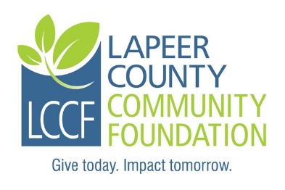
Lapeer County Community Foundation
Dr. James and Doris Richardson
Scholarship Application
Criteria:
a. Must be a current resident of Lapeer County or Genesee County and have graduated from Lakeville schools or a Lapeer County school.
b. Must be at least a second year-enrolled college applicant in a pre-science medical professional program such as medical, dental, nursing, or physician’s assistant, physical therapy, or technical support position such as X-ray or lab.
c. Must hold a 3.2 GPA or higher in post-secondary studies.

Instructions: Complete the fillable application, print ,sign and date. It may be necessary to click on “Enable Editing” command at the top of the screen.

Personal Information:

Last Name: | First name: | Middle Initial:
Address: |  | City:
Zip Code: | Township: | County:
Home phone: | Student cell: | Date of Birth:
Student ID #: | Student email:
Parents/Guardians: |  | Annual household income:
# of Children in Household: |  | # of children in college:

Student Experiences and Activities:

High School Attended: | Graduation date:
Colleges attended/degree earned(if any):

College/program attending: | Anticipated cost for one year: | Current GPA:
Anticipated profession or area of vocational interest:

Community and non-school activities:

Employment history (Name of employer, name of manager, and position (up to 3 employers):

List of other scholarships, grants or financial aid applied for:

Name Amount of award Awarded? Yes, No, Pending

Student Essay Question (Limit your answer to 200 words).

What do you hope to achieve in the medical field?

How did you hear about this scholarship?

I, the undersigned, hereby acknowledge the information provided on this application is true and correct to the best of my knowledge.

Student applicant: ___________________________________________Date:________________

Required Attachments:
- Current transcript showing credits earned and current GPA.
- Please submit an original signed application including all attachments along with six complete copies for a total of seven complete packets.
- Copy of your current year FAFSA Student Aid Report (SAR). Please only submit the page that shows the EFC (Estimated Family Contribution).
- A letter of recommendation. (Optional)

Submission Instructions:
- Please do not submit double sided copies or use staples.
- Please submit an original signed application including all attachments along with six complete copies for a total of seven complete packets.
- Please paperclip each complete packet.
- Please mail all seven packets in one envelope to the committee and address listed below.
- If you are applying for more than one scholarship through LCCF, pleas do not combine different named scholarships in one envelope as they have different committees.

Application must be postmarked NO LATER THAN Friday, March 12, 2021.

Mail to: Dr. James & Doris Richardson Scholarship Committee
Lapeer County Community Foundation
235 West Nepessing Street
Lapeer, MI 48446

Questions may be directed to:
Nancy Boxey, Executive Director
Phone: 810 664-0691
Email: nboxey@lapeercountycf.org

