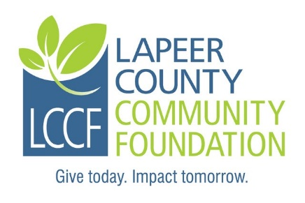
Lapeer County Community Foundation
FRED PASTERNAK MEMORIAL SCHOLARSHIP
The Fred Pasternak Memorial Scholarship was established to honor the legacy of Fred Pasternak and his commitment to the field of agriculture and skilled trades.
The Fred Pasternak Memorial Fund was established to provide scholarships for current graduating seniors of North Branch Area Schools residing in Lapeer County. Applicants must be pursuing post-secondary studies at a community college or university, in the field of agriculture or a vocational or technical career training and earn a degree, certificate or apprenticeship from an accredited program.
Must have a cumulative GPA of 3.5 or higher.

Instructions: Complete the fillable application, print, sign, and date. It may be necessary to click on “Enable Editing” command at the top of the screen.

Personal Information:
Last Name: | First name: |  | Middle Initial:
Address: |  |  | City:
Zip Code: | Township: |  | County:
Home phone: | Student cell: |  | Date of Birth:
Student ID #: | Student email:
Parents/Guardians:

Adjusted Gross Household Income: | # of Children in Household: |  | # of Children in College:

Student Experiences and Activities:
High School Attending: | Graduation date: | Cumulative GPA:
Employment history:

School related activities/Non-School related activities:

Intended occupation:

Colleges accepted to (in order of preference): Anticipated costs for 1 year:
1)
2)
3)

List of other scholarships, grants or financial aid applied for:

Name Amount of award Awarded? Yes, No, Pending

Student Essay Questions (Limit your answer to 300 words or less per question).

- How have North Branch Area Schools impacted your future goals?

- How have you contributed to the North Branch Community?

- Explain the importance of your intended field of study in the world today?

How did you hear about this scholarship?

I, the undersigned, hereby acknowledge the information provided on this application is true and correct to the best of my knowledge.

Student applicant: ___________________________________________Date:________________

Required Attachments:
1. Current transcript showing credits earned and current GPA.
2. Copy of your SAT scores if you are a graduating high school senior.
3. Copy of your current year FAFSA Student Aid Report (SAR). Please only submit the page that
shows the SAI (Student Aid Index).
4. A letter of recommendation (optional).

Submission Instructions:
- Please do not submit double sided copies or use staples.
- Please submit an original signed application including all attachments along with six complete copies for a total of seven complete packets.
- Please paperclip each complete packet.
- Please mail all seven packets in one envelope to the committee and address listed below.
- If you are applying for more than one scholarship through LCCF, please do not combine
different named scholarships in one envelope as they have different committees.

Application must be postmarked NO LATER THAN Friday, March 10, 2023.

Mail to:
Fred Pasternak Memorial Scholarship Committee
LCCF
235 W. Nepessing Street
Lapeer, MI 48446

Questions may be directed to:

Nancy Boxey, Executive Director
Phone: 810 664-0691
Email: nboxey@lapeercountycf.org
