624 W Nepessing Street,
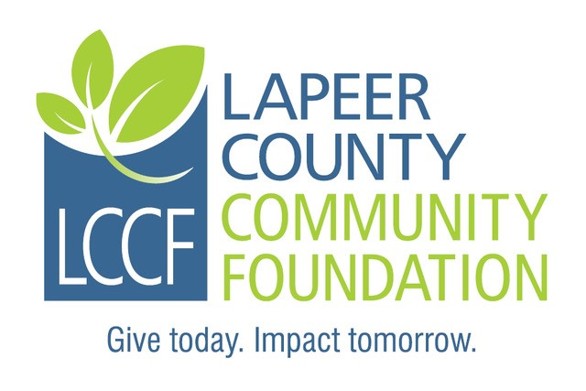
Suite 106
Lapeer, MI 48446
810.664.0691

LAPEER COUNTY COMMUNITY FOUNDATION
Donor-Advised Fund Grant Payment Request

In order to request disbursement of grant money from your fund, you will need to complete and submit this form, signed by a person authorized to act on behalf of your organization or fund.

Fund Name: Date:

Grantee: (Name of person or organization receiving the grant)
Grantee Address:
City: State: Zip:
Phone: email:
Description of Grant:
Amount of Grant: $ Effective Date:
Fund Contact Person: Title:

The authorized official signing this request is verifying:
- This grant will not result in the donor, advisors or related parties receiving any personal or material benefit, compensation or expense reimbursement, exchange of goods or services.
- The above-suggested distribution(s) does not represent the payment or satisfaction of any pledge or other legally enforceable obligation and is not made for lobbying purposes or to support a political campaign. If any benefits or privileges are offered in connection with such distribution(s), I have not and will not accept them.
- Note: All recipient organizations must meet IRS classification as a non-profit 501(c)(3) organization

________________________________________ ________________________________________
Signature of Authorized Fund Official Printed Name & Title

